Social Media Post

Social Media Post: (<https://www.reddit.com/r/Python/comments/fzxori/i_made_a_machine_learning_based_ddos_detection/>) This post will increase the visibility of the project. I will use r/Python as the platform for this post as similar projects have been well received: <https://www.reddit.com/r/Python/comments/dfdtbs/automated_brightness_on_a_laptop_using_machine/>,<https://www.reddit.com/r/Python/comments/fudlk3/i_made_my_first_machine_learning_project_in/>. **Further justification for this can be seen in the Daily Diary under the Market Analysis (March 28th) section.**

The structure of these posts seems quite simple. They consist of an image or video of the program, along with a catchy headline(Examples: <https://www.reddit.com/r/Python/comments/fzwbcx/i_made_a_face_recognition_program/>,<https://www.reddit.com/r/Python/comments/g05323/ai_learns_to_play_flappy_bird/>). I will adopt this form, as this has been the most well received. It’s odd that a social media post should be so barren of info, but I believe that most explanation is given via the comment section.

I’m choosing the Decision tree diagram as the image I will use in the social media post. It best represents the project and, in my opinion, looks quite interesting.

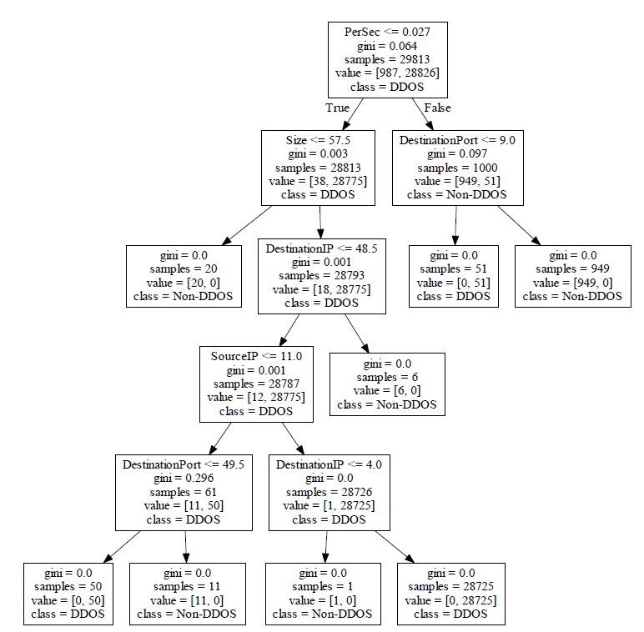

In terms of the tagline, I’m going to go with “**I made a machine learning based DDOS detection program using sk-learn.**” This is because most of the posts contain a prefix of “I made a…”. I’m include “sk-learn” so that the users of /r/Python know that I used Python in the project. I have omitted mention of the raspberry pi as it doesn’t relate to the Python discussions on this forum (Even though “pi” stands for python interpreter…)